ComMOCSvc service extension for file processing
GEA File Converter
Conception Document

Reference : |  |  |  | Revision : C |  | Date : | 23/02/2004
Verified by: |  |  | Date : |  |  | Visa :
Approved by: |  |  | Date : |  |  | Visa :
Author : | T. Cvitanic
Project Name : |  | HAC
Project Redo :
Diffusion list:

HISTORY EVOLUTION

Version | Date | Evolution | Author
A | 4.11.2003 | Creation | TC
B | 17.11.2003 | The conversion procedure is simplified | TC
C | 23.02.2004 | Event mapping has been corrected and payment type mapping has been added | TC

TABLE OF CONTENTS

1. Introduction 4
1.1. Document presentation 4
1.2. Glossary 4
1.3. Referent documents 5
2. MODULE PrEsentation 6
2.1. Functional diagramS 6
2.1.1. Module initialization 6
2.1.2. File processing 7
2.1.3. File conversion 8
2.1.3.1. Transaction message conversion 10
2.1.3.2. Event Message conversion 10
2.2. Module parameters 13

Introduction

Document presentation
The purpose of this document is to describe the ComMOCSvc service extension module that converts the GEA messages to CSSI messages.
The module contains three exported functions that are described in the "Dossier de conception de CommocSvc.doc" document. The ComMOCSvc service uses these three functions to initiate the module, process detected file and close the module.

Glossary
MOC Central system
GEA Grenobloise d’Electronique et d’Automatismes

Referent documents
Dossier de conception de CommocSvc.doc | Revision: B
Manuel de maintenance de CommocSvc.doc | Revision: B

MODULE PrEsentation
The GEA messages are stored in the GEA file created by the GEA communication server. The GEA communication server receives messages from the GEA exit lanes over TCP/IP socket and stores them in the file. One GEA file contains messages from many GEA exit lanes.
The GEA file converter module reads line by line from the GEA file. It decodes the GEA message header and detects the type of the GEA message. Depending on the GEA message type the module calls the appropriate conversion. Successfully converted messages are stored into the CSSI file in the directory that is processed by the ToDBSvc service.

Functional diagramS
The service is checking the LocalMailIn directory periodically. As soon as the new file is detected it calls the WorkerProcessFileEx function that processes the file. During the conversion the module uses the LocalTemp and LocalContext directories in which it stores the temporary and context files. The context files are used to save the transaction data in the case of the service crashing or service restart during the file processing. The purpose of the context files will be explained in the next document sections.

Module initialization
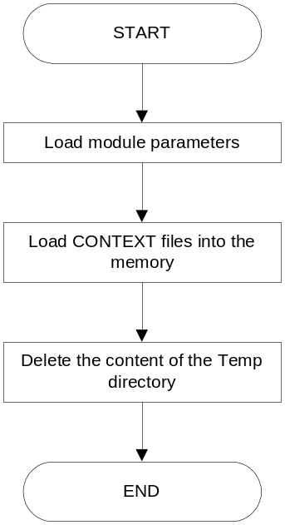

During the module initialization (at service startup) the module deletes all the temporary files if they exist. The temporary files exist only in the case of the service restart or service crashing during the file conversion. Otherwise, the module moves temporary files as soon as the module finishes the file conversion. Only context files remain after the file conversion. The context file contains the part of the transaction data that are still not converted and module loads these data into the memory at the module initialization. In addition, the context files contain information about current file counter that is increased after each successfully conversion. This counter is used for the CSSI file name creation.

File processing
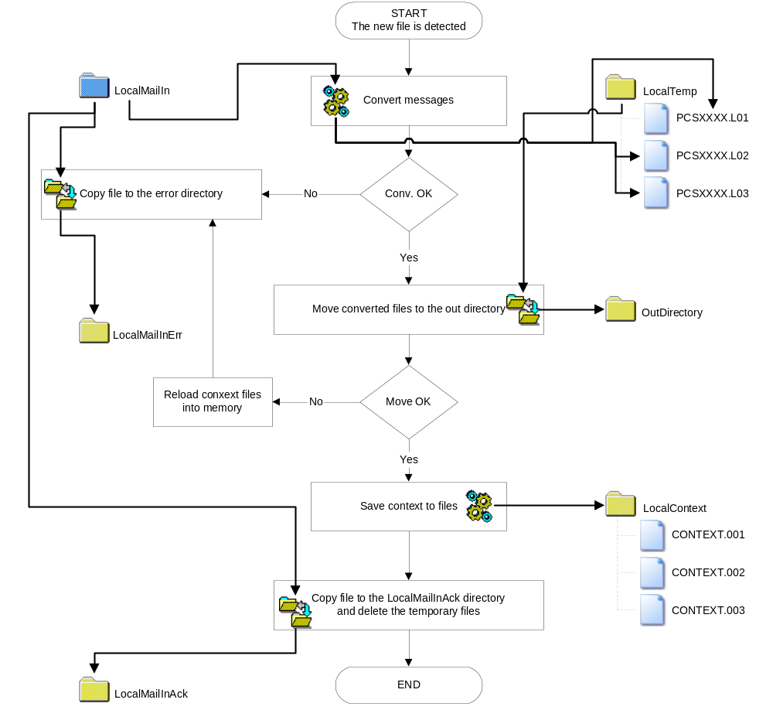
The GEA file contains mixed messages received from all the plaza lanes. In addition, between the two items of the transaction message it is possible to find other messages. The CSSI file contains messages from only one lane and many GEA transaction messages can be converted in only one CSSI transaction message.
The module reads message by message from the GEA file. After successful conversion it stores the converted message to the appropriate file. The lane number and the plaza number found in the GEA message header determine the file name in which the converted message will be stored. The file name also contains the counter that is increased for each lane after the successful GEA file conversion. If GEA file contains the normal messages (not re-sent) the converted files will be stored in the file with the following naming convention:
MSG.PCSPPPP.LLLLL.SCCCCCCCC
Otherwise, they will be stored in the file with the following naming convention:
BAK.PCSPPPP.LLLLL.SCCCCCCCC

Note:
- PPPP – Plaza number
- LLLL – Lane number
- CCCCCCCC – File counter

File conversion
The module contains the memory structure for each lane in which stores the file counter, the lane number and unconverted messages. If the module detects the transaction item that can't be converted (if it is not the last transaction item) it stores the item in the appropriate memory structure. Otherwise, it converts the message and stores the converted message in the CSSI file. If the conversion is successfully finished the module saves the memory structures into different files under the LocalContext directory. Each memory structure (for each lane) is stored in separate file named CONTEXT.LLL where LLL is lane number.
Since, the module loads the context files into the memory at the module start-up the unconverted transaction items will not be lost in the case of the service restart.
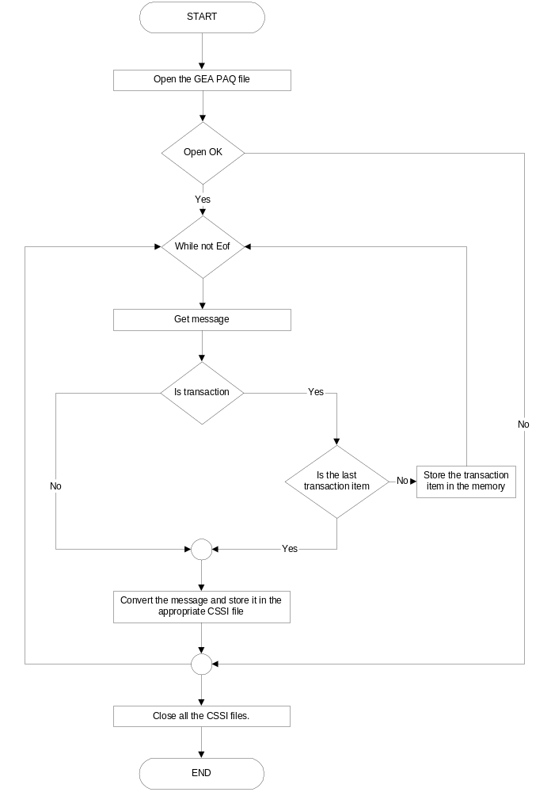

The converted files are stored in the LocalTemp directory until the conversion is finished. When the conversion is finished the converted files will be moved in the LocalOut directory where the ToDBSvc service will load them into the database and delete if the loading is successful.

Transaction message conversion
Conversion table
Payment type | GEA data |  |  |  | CSSI data
Payment type | Billing Code | MOP Obs. Code | Seq. Obs. Code | Pas. Obs. Code | PMT Type | PMT Sub-type
Violation | 0 | - | - | 3 | 1 | 1
Emergency | 0 | - | C | - | 96 | 1
Cash | 1 | - | - | - | 3 | 1
Check | 5 | - | - | - | 7 | 1
Coupon | 6 | - | - | - | 98 | 1
IOU | 7 | - | - | - | 10 | 1
Freeway (keyed), police | 8 | 52 | - | - | 2 | 2
Freeway (keyed), ambulance | 8 | 53 | - | - | 2 | 3
Freeway (keyed), fire brigade | 8 | 54 | - | - | 2 | 4
Freeway (keyed), UN forces | 8 | 55 | - | - | 2 | 5
Freeway (keyed), humanitarian org. | 8 | 56 | - | - | 2 | 14
Freeway (keyed), others | 8 | 57 | - | - | 2 | 7
Freeway (keyed), HAC vehicles | 8 | 58 | - | - | 2 | 12
Freeway (keyed), HAC permission | 8 | 59 | - | - | 2 | 11
Freeway (keyed), disabled persons | 8 | 60 | - | - | 2 | 10
Freeway (keyed), Croatian army | 8 | 61 | - | - | 2 | 13
Foreign currency | 9 | - | - | - | 9 | 1
Credit card | 12 | - | - | - | 4 | 1
Prepaid CSC | 15 | - | - | - | 14 | 1
Prepaid TAG | 16 | - | - | - | 6 | 1
Freeway (CSC), police | 27 | 52 | - | - | 2 | 2
Freeway (CSC), ambulance | 27 | 53 | - | - | 2 | 3
Freeway (CSC), fire brigade | 27 | 54 | - | - | 2 | 4
Freeway (CSC), UN forces | 27 | 55 | - | - | 2 | 5
Freeway (CSC), humanitarian org. | 27 | 56 | - | - | 2 | 14
Freeway (CSC), others | 27 | 57 | - | - | 2 | 7
Freeway (CSC), HAC vehicles | 27 | 49,58 | - | - | 2 | 12
Freeway (CSC), HAC permission | 27 | 59 | - | - | 2 | 11
Freeway (CSC), disabled persons | 27 | 50,60 | - | - | 2 | 10
Freeway (CSC), Croatian army | 27 | 61 | - | - | 2 | 13
Voucher | 34 | - | - | - | 11 | 1
Monthly subscription | 37 | - | - | - | 2 | 8
Annual subscription | 38 | - | - | - | 2 | 9

Event Message conversion
Conversion table
Label | GEA exceptional data |  |  | CSSI events
Label | Eq. Code | Ano. Code | Status | Cat. | Sub-cat. | Status
Software start | 01 | 002 | 2 | 1 | 1 | 2
CXP comm. Error | 02 | 001 | 0 | 5 | 4 | 0
CXP presence loop fault | 02 | 001 | 1 | 5 | 4 | 1
CXP presence loop permanent detection | 02 | 105 | 0/1 | 5 | 4 | 0/2
MCR comm. error | 06 | 001 | 0/1 | 8 | 2 | 0/1
MCR reading error | 06 | 002 | 0/1 | 8 | 4 | 0/1
MCR ISO 3 writing error | 06 | 003 | 0/1 | 8 | 5 | 0/1
MCR jam | 06 | 004 | 0/1 | 8 | 3 | 0/1
ZIP comm. error | 08 | 001 | 0/1 | 7 | 2 | 0/1
ZIP reading error | 08 | 002 | 0/1 | 7 | 1 | 0/1
RP comm. error | 09 | 001 | 0/1 | 6 | 2 | 0/1
RP paper jam | 09 | 004 | 0/1 | 6 | 4 | 0/1
RP paper lower | 09 | 006 | 0/1 | 6 | 3 | 0/1
RP end of paper | 09 | 007 | 0/1 | 6 | 3 | 0/2
RP temperature high | 09 | 008 | 0/1 | 127 | 1 | 0/1
RP cutter problem | 09 | 009 | 0/1 | 127 | 2 | 0/1
RP high head problem | 09 | 010 | 0/1 | 127 | 3 | 0/1
VMS status lane failure | 10 | 001 | 0/1 | - | - | -
Antenna comm. Error | 31 | 101 | 0/1 | 17 | 2 | 0/1
Antenna writing error | 31 | 102 | 0/1 | 127 | 4 | 0/1
Antenna Pertel default | 31 | 103 | 0/1 | 17 | 1 | 0/1
Antenna marker default | 31 | 104 | 0/1 | - | - | -
TGB comm. Error | 31 | 201 | 0/1 | 18 | 2 | 0/1
TGB writing error | 31 | 202 | 0/1 | 127 | 6 | 0/1
TGB Pertel default | 31 | 203 | 0/1 | 18 | 1 | 0/1
TGB marker default | 31 | 204 | 0/1 | 127 | 7 | 0/1
CSC comm. error | 35 | 001 | 0/1 | 16 | 2 | 0/1
CSC writing error | 35 | 002 | 0/1 | 16 | 4 | 0/1
CSC writing and transaction error | 35 | 003 | 0/1 | 16 | 4 | 0/1
AVC comm. Error | 45 | 101 | 0/1 | 10 | 2 | 0/1
AVC optical barrier default | 45 | 107 | 0/1 | 5 | 11 | 0/1
AVC optical barrier always activated | 45 | 110 | 0/1 | 5 | 11 | 0/2
AVC loop default | 45 | 111 | 0/1 | 5 | 99 | 0/1
AVC treadles 1 default | 45 | 113 | 0/1 | 10 | 3 | 0/1
AVC treadles 2 default | 45 | 114 | 0/1 | 10 | 4 | 0/1
AVC treadles 3 default | 45 | 115 | 0/1 | 10 | 5 | 0/1
AVC treadles 4 default | 45 | 116 | 0/1 | 10 | 6 | 0/1
AVC height detection default | 45 | 121 | 0/1 | 127 | 8 | 0/1
EPT comm. error | 49 | 001 | 0/1 | 19 | 2 | 0/1
Manual barrier open | 80 | 009 | 2 | 127 | 9 | 0
Manual barrier closed | 80 | 010 | 2 | 127 | 9 | 1
Overhead traffic light red | 80 | 013 | 2 | 5 | 14 | 0
Overhead traffic light green | 80 | 014 | 2 | 5 | 14 | 1
Reversing | 80 | 015 | 2 | 4 | 16 | 1
Class discrepancy | 80 | 016 | 2 | 127 | 10 | 1
Passage simulation | 80 | 018 | 2 | 4 | 9 | 1
Forced passage | 80 | 019 | 2 | 4 | 11 | 1
Unspecified class | 80 | 020 | 2 | 127 | 11 | 1
Emergency | 80 | 022 | 2 | 127 | 12 | 1
MOP in black list | 80 | 024 | 2 | 127 | 13 | 1
Operator MOP | 80 | 025 | 2 | 127 | 14 | 1
MOP cancellation | 80 | 026 | 2 | 4 | 13 | 1
Plaza contentious | 80 | 028 | 2 | 127 | 15 | 1
Opening lane | 80 | 031 | 2 | 1 | 4 | 1
Closing lane | 80 | 032 | 2 | 1 | 4 | 0
Refusal of remote control | 80 | 033 | 2 | 127 | 16 | 1
PCS communication | 80 | 036 | 2 [0/1] | 2 | 2 | 0/1
Beginning of break | 80 | 043 | 2 | 127 | 17 | 1
End of break | 80 | 044 | 2 | 127 | 18 | 1
Transit ticket problem | 80 | 045 | 2 | 127 | 19 | 1
Towed vehicle | 80 | 058 | 2 | 127 | 20 | 1
Vehicle with badge refused on ETC lane | 80 | 060 | 2 | 127 | 21 | 1
Rest of the magnetic reader in the reading/invalidation sequence | 80 | 069 | 2 | 127 | 22 | 1
Upgrade of the lane software on the next reboot | 80 | 077 | 2 | 127 | 23 | 1
PCS failure loading the table data in ORACLE DB | 85 | 011 | 0/1 | - | - | -
PCS failure loading the toll data in ORACLE DB | 85 | 012 | 0/1 | - | - | -
PCS failure purge of the ORACLE DB | 85 | 013 | 0/1 | - | - | -
PCS failure of the configuration | 85 | 014 | 0/1 | - | - | -
CTC server comm. error | 86 | 001 | 0/1 | - | - | -
POS comm. error | 88 | 001 | 0/1 | - | - | -
POS initialization | 88 | 002 | 2 | - | - | -

Events connected to the parameter list manipulation:
Conversion table
Label | GEA exceptional data |  |  | CSSI events
Label | Eq. Code | Ano. Code | Status | Cat. | Sub-cat. | Status
TFT open/read error | 50 | 001 | 2 | 3 | 4 | 1
TFT header error | 50 | 002 | 2 | 3 | 4 | 1
TFT type of table error | 50 | 003 | 2 | 3 | 4 | 3
TFT network error | 50 | 004 | 2 | 3 | 4 | 2
TFT plaza error | 50 | 005 | 2 | 3 | 4 | 3
TFT version error | 50 | 006 | 2 | 3 | 4 | 3
TFT size records error | 50 | 007 | 2 | 3 | 4 | 3
TFT number of records error | 50 | 008 | 2 | 3 | 4 | 3
Journey table | 51 | As TFT | 2 | 127 | 24 | As TFT
Currency table | 53 | As TFT | 2 | 3 | 7 | As TFT
Authorized magnetic card table | 54 | As TFT | 2 | 3 | 9 | As TFT
Authorized staff table | 56 | As TFT | 2 | 3 | 6 | As TFT
Black list for bank and credit card | 57 | As TFT | 2 | 3 | 13 | As TFT
Blacklist for CSC | 58 | As TFT | 2 | 3 | 14 | As TFT
White list | 59 | As TFT | 2 | 127 | 25 | As TFT
Constant table | 60 | As TFT | 2 | 127 | 26 | As TFT
Product table | 62 | As TFT | 2 | 3 | 5 | As TFT
List of authorized media types | 63 | As TFT | 2 | 127 | 27 | As TFT
Media table | 64 | As TFT | 2 | 127 | 28 | As TFT
Authorized reloading value | 68 | As TFT | 2 | 127 | 29 | As TFT
General table | 70 | As TFT | 2 | 127 | 30 | As TFT

Module parameters
The module parameters are stored under the HKEY_LOCAL_MACHINE\System\CurrentControlSet\Services\CommocSvc\Parameters\Workers\ModuleName registry key where the ModuleName can be any string. It means that the user can start many instances of the module and he can give them different names (and adjust different parameters).

Module registry parameters description
Variable name | Variable type | Description
Dll | String | csr_cmworkgeaimg.dll – the name of the library from which the ComMOCSvc service calls the module functions.
PollingPeriod | Dword | This parameter adjusts the time between two checking of directory (in milliseconds).
TraceFile | String | Name of the module trace file.
LocalMailIn | String | This is the directory where the GEA image files are stored. The ComMOCSvc service checks this directory to detect if there is any new file to process.
LocalMailInAck | String | Successfully processed GEA image files are stored in this directory.
LocalMailInErr | String | Unsuccessfully processed GEA image files are stored in this directory.
LocalWork | String | Sorted and context files are stored in this directory.
LocalTemp | String | Converted CSSI files are stored in this directory during the conversion.
OutDirectory | String | This is the directory where the successfully extracted pictures are stored.
MaxAckFiles | Dword | Maximal number of files stored in the LocalMailInAck directory.
MaxAckKB | Dword | Maximal cumulative size of files stored in the LocalMailInAck directory.
MaxErrFiles | Dword | Maximal number of files stored in the LocalMailInErr directory.
MaxErrKB | Dword | Maximal cumulative size of files stored in the LocalMailInErr directory.
NameMask | String | The file name mask. The module will not process the files that not belong to defined file name mask.
InAndAckDelete | Dword | If this parameter is set to 1 and if the service detects the same file in the LocalMailIn and LocalMailInAck directory the files will be deleted.
InAndErrDelete | Dword | If this parameter is set to 1 and if the service detects the same file in the LocalMailIn and LocalMailInErr directory the files will be deleted.

